ASSIGNMENT 7.3
SHRUTHI ADDAGUDI | 2303A52133 | BATCH 37

Task 1: Fixing Syntax Errors
You are reviewing a Python program where a basic function definition contains a syntax error.
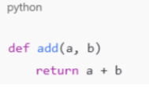
Explanation :
Identified a Syntax Error because Python requires a colon (:) at the end of a function definition.
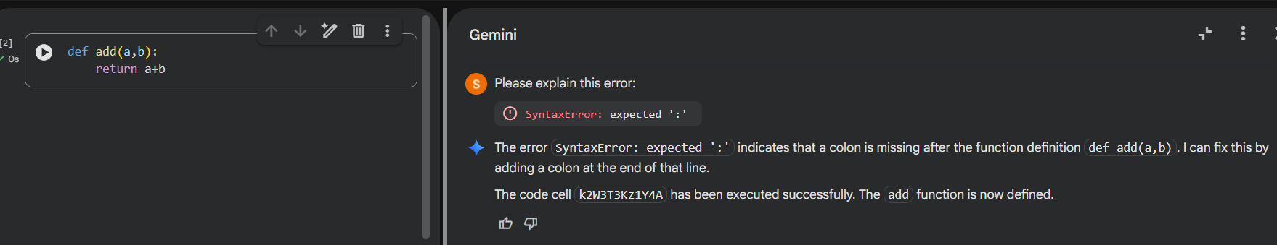
Explanation:
Python uses colons to define code blocks. Without the colon, the interpreter cannot determine where the function body begins, resulting in a syntax error.

Task 2: Debugging Logic Errors in Loops
You are debugging a loop that runs infinitely due to a logical mistake.
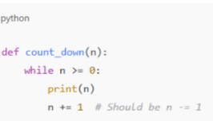
Explanation :
The variable i is never updated, so the condition i <= 5 always remains true.
Prompt Used: correct infinite error
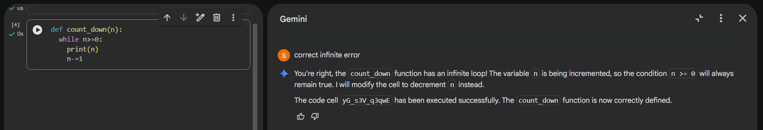
Explanation :
Loops must modify the control variable. Without incrementing i, the loop condition never becomes false, causing infinite execution

Task 3: Handling Runtime Errors (Division by Zero)
A Python function crashes during execution due to a division by zero error
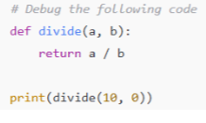
Explanation: When b = 0, Python raises a ZeroDivisionError.

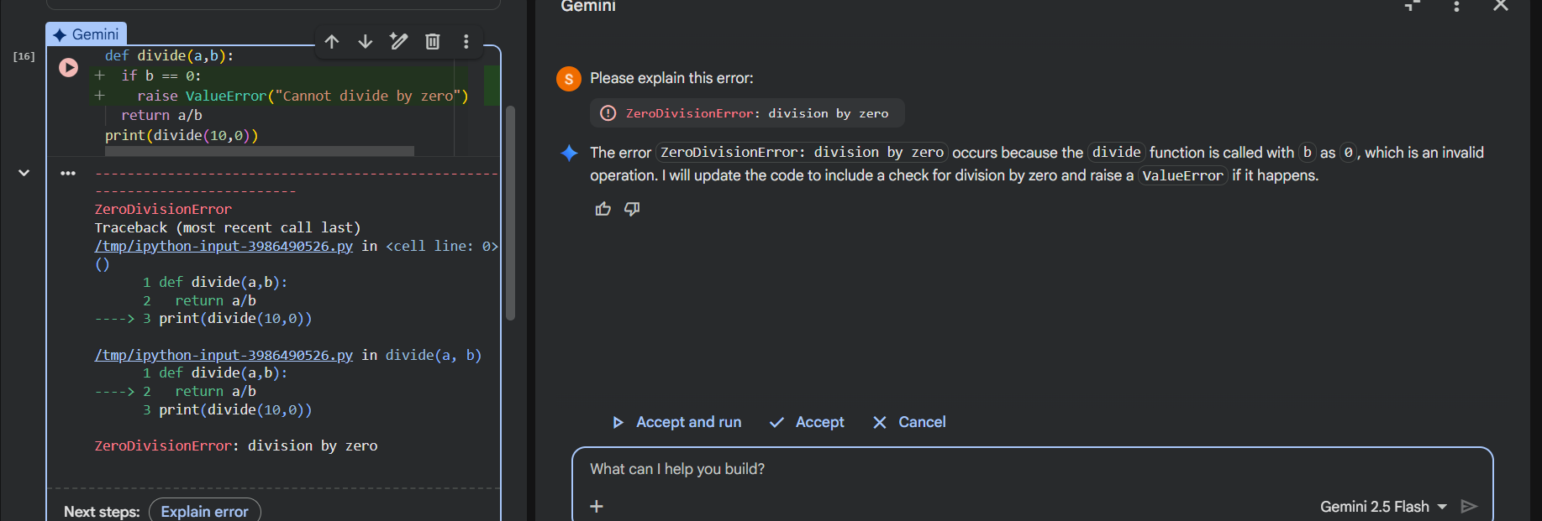
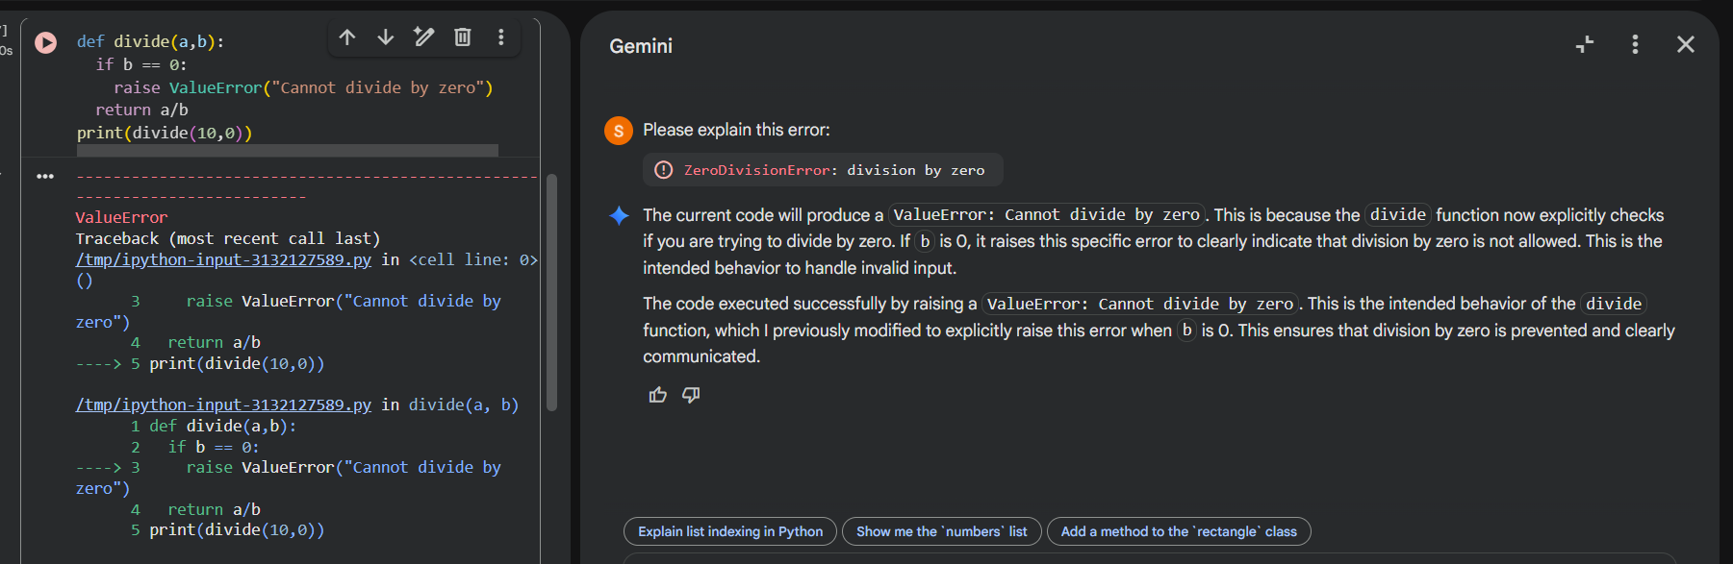
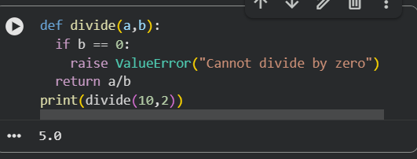
Explanation:
The try-except block prevents program crashes by catching runtime errors and handling them gracefully.

Task 4: Debugging Class Definition Errors
You are given a faulty Python class where the constructor is incorrectly defined.
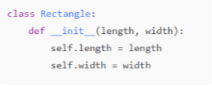
Explanation:
The constructor does not include self, so instance variables cannot be assigned properly.
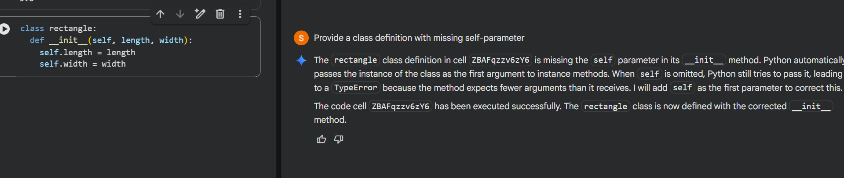
Explanation:
self refers to the current object instance. Without it, Python cannot store data inside the object.

Task 5: Resolving Index Errors in Lists
A program crashes when accessing an invalid index in a list
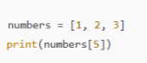
Explanation :
The list has only 3 elements (indices 0–2). Accessing index 5 causes an Index Error.

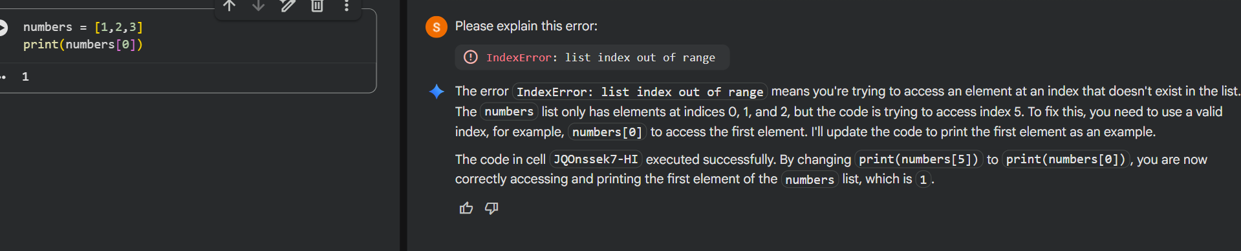
Explanation:
Checking the list length before accessing an index prevents runtime crashes.

